Source https://pinpointtraveler.com/tour/hiroshima-peace-memorial-to-miyajima/
__________________________________________________________

Hiroshima to Miyajima: A Day of Peace, Memory & Island Beauty
__________________________________________________________
★★★★★ 4.7/5 28 reviews

Add to wishlist ♡

__________________________________________________________

8 hours | From €75 per person

🏕  Image | 🏕  Image | 🏕  Image | 🏕  Image | 🏕  Image | 🏕  Image

__________________________________________________________
About This Tour
Welcome to Hiroshima — a city where history is held with honesty, and peace is practiced with purpose.
This full-day guided experience moves from the solemn reflections of the Peace Memorial Park and Museum to the natural and spiritual beauty of Miyajima Island, creating a day that is equal parts meaningful and uplifting.
You’ll begin at the Peace Memorial, standing before the Atomic Bomb Dome — a UNESCO World Heritage Site and enduring symbol of resilience. With a knowledgeable, compassionate guide, you’ll explore the park and museum at a thoughtful pace, gaining deeper context and connection to the events of August 6, 1945, and to Hiroshima’s role today as a global voice for peace.
__________________________________________________________
What’s Waiting for You
- Duration: 8 hours (approx.)
- Group Size: Up to 8 guests (private option available)
- Languages Available: English
- Season: Available year-round
- Meeting Point: 7-Eleven outside Hiroshima Peace Memorial Park (optional station pickup available for an added fee; details provided after booking)
__________________________________________________________

Check Dates & Availability

Select participants: (Age 99 and younger) - 1 +

Choose date:
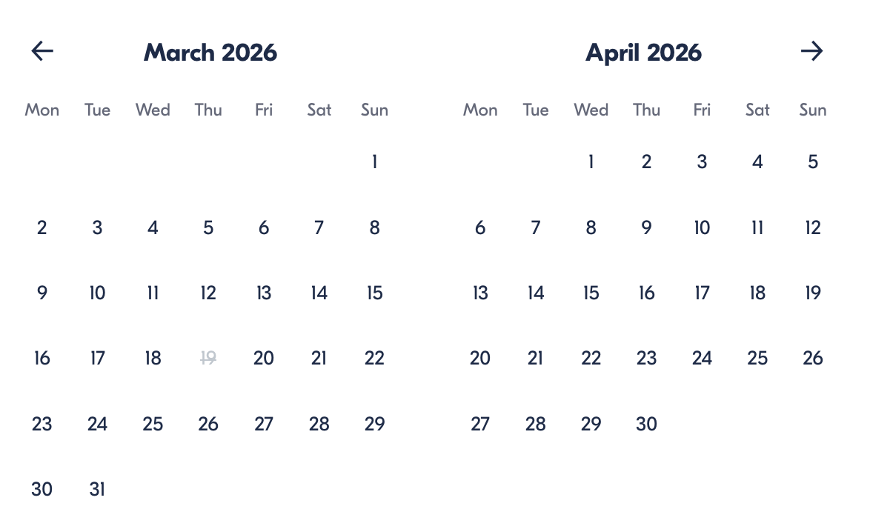

Check Availability

opens:

Participants: 2 March 16, 2026

Hiroshima to Miyajima: A Day of Peace, Memory & Island Beauty

- Duration: 8 hours (approx.)
- Offered in: English
- Starts at: 10:30 AM

Cancellation:

- Full Refund up to 24 Hours Before Departure: Cancel up to 24 hours before departure for a full refund. Notify us via email, and we’ll confirm your cancellation.

Price breakdown: 2 Participants x €75

Total: €150

The total price includes all taxes and fees.

Add to cart Book now

__________________________________________________________
Tour Features
- Historic Landmarks: Walk through Peace Memorial Park and visit the Atomic Bomb Dome — places that carry history with gravity and clarity.
- Professional Guide: Real English, real skills, and great personalities. Your guide brings empathy, context, and deep local knowledge.
- Fully-Narrated Tour: You’re never left wandering alone. Your guide supports you throughout the day with stories, explanations, and practical assistance.
- A Tale of Contrast: Experience Hiroshima’s solemn memorial spaces, then shift into the calm, sacred beauty of Miyajima Island.
- Easy Access: Meet at a clearly marked spot right by the Peace Memorial Park, with an optional Hiroshima Station pickup (added fee).
__________________________________________________________
Detailed Itinerary
- Day 1
Hiroshima Peace Memorial Park & Museum (Approx. 2 hours)
We begin at Hiroshima’s Peace Memorial Park and Museum — a powerful, reflective introduction to the city’s history and global message of peace. Your guide walks you through key sites, including the Atomic Bomb Dome, cenotaph, and memorial flame, then supports your visit inside the museum with thoughtful context and pacing.

Transit to Miyajima Island (Approx. 75 minutes)
Hiroshima’s public transit network is part of daily life here — and we use it as locals do. You’ll ride a combination of tram/train and ferry, including a scenic boat crossing that begins the shift from city to island serenity.

Itsukushima Shrine & Tenshinkaku (Approx. 90 minutes)
Arriving on Miyajima, we visit the iconic Itsukushima Shrine, where the torii gate can appear to float on the sea depending on the tide. Your guide explains the shrine’s spiritual meaning, historical role, and the unique relationship between architecture and nature here. We also visit Tenshinkaku, the “Pavilion of Heavenly Spirits,” a calmer cultural space that adds depth beyond the famous highlights.

Lunch Break on Miyajima (Approx. 45 minutes)
Enjoy lunch at your own pace with guidance and recommendations. Top local favorites include:
- Hiroshima-style okonomiyaki
- Fresh seafood
- Momiji manju (maple-leaf cakes)

Add’l Time on Miyajima Island (Approx. 2 hours total)
We balance structure and freedom:
- 1 hour guided island stroll
- Explore scenic paths, nature, and viewpoints beyond the main shrine area, with photography-friendly stops and cultural insights.
- 1 hour free time
- Wander shopping streets, sample street food, visit extra shrines/temples, or simply enjoy the coastline and atmosphere.

Transit Back to Hiroshima Station
Your guide escorts you back to Hiroshima Station and can assist with directions to your next destination.
__________________________________________________________
Included in Price
- Professional English-speaking guide
- Guided visit to Peace Memorial Park & Museum (commentary and support throughout)
- Guided visit to Itsukushima Shrine area & Miyajima highlights
- Public-transit navigation and full-day assistance
- Time structured for both guided exploration and independent discovery
__________________________________________________________
Not Included
- Lunch and personal snacks
- Personal expenses (souvenirs, extra treats, etc.)
- Travel insurance
- Any additional activities/meals not listed in the itinerary
- Optional Hiroshima Station pickup (available for an added fee)
__________________________________________________________
Who Should Avoid This Tour
- Travelers Seeking a Light, Casual City Stroll: This tour includes emotionally heavy historical content and is designed to be meaningful, not purely leisure-focused.
- Guests Who Prefer Fully Private Transportation: This experience uses public transit (tram/train/ferry) to travel like locals and keep the day smooth and authentic.
- Those With Limited Mobility Without Assistance: There is a fair amount of walking, standing, and transit navigation throughout the day.
__________________________________________________________
Important Trip Info
- Please wear comfortable shoes — walking is an essential part of the experience.
- Bring layers (the weather can shift, especially on the water).
- Ferry schedules and routes can vary slightly depending on the day.
- This tour runs rain or shine (except in extreme conditions).
__________________________________________________________

Cancellation Policy

Full Refund up to 24 Hours Before Departure
Cancel up to 24 hours before departure for a full refund. Notify us via email, and we’ll confirm your cancellation.
Changes Made by Us
We may modify your itinerary due to unforeseen circumstances. In case of significant changes, we’ll offer an alternative tour or refund the price difference.
Circumstances Beyond Our Control
We are not liable for cancellations or changes due to events such as war, natural disasters, or severe weather.
Your Responsibility
You are responsible for your actions. If your behavior disrupts others or causes damage, you’ll be held liable for any costs incurred.
__________________________________________________________
What Our Clients Are Saying

Overall rating  4.7/5  ★★★★★  Based on 28 reviews | Review summary  Guide 4.5/5  Transportation 4.6/5  Service 4.7/5  Organisation 4.5/5

Filter  - All traveller types  - Couples  - Group of friends  - Families  By star rating  - All star ratings  - 5 stars  - 4 stars  - 3 stars  - 2 stars  - 1 star | Search reviews (e.g., guide)  Sort by:  - Top picks  - Latest reviews  - Best ratings  - Lowest ratings
__________________________________________________________
★★★★★ Sharon – Australia
Ken explained everything so meticulously, and nothing was a bother. Peace Park, Miyajima, amazing lunch — truly unforgettable. Highly recommend it!

★★★★★ Daniel – Portugal
Fantastic guide and a great mix of meaningful history and beautiful scenery. A day that really stayed with me.

★★★★★ Tray – Spain
Very good tour, we covered the main landmarks and learned a lot about the culture and history. Great pace and excellent guidance.

See more reviews
__________________________________________________________

Meta tags

Page - Hiroshima to Miyajima: A Day of Peace, Memory & Island Beauty

Title: Hiroshima to Miyajima: A Day of Peace, Memory & Island Beauty | Travellio Global

Description: Explore Hiroshima’s Peace Memorial Park and Miyajima Island in one meaningful day tour. Visit iconic landmarks, ride the ferry, and discover UNESCO heritage sites with a local guide.

H1 - Hiroshima to Miyajima: A Day of Peace, Memory & Island Beauty
__________________________________________________________

